

**Cuisine-Specific Map – Italian Restaurants Documentation**

**Step 1 -** Installing **folium** module. You can do it inside Jupyter Notebook as shown below

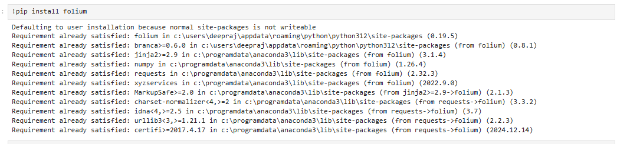

**Step 2 -** Installing **IPython** module. You can do it inside Jupyter Notebook as shown below

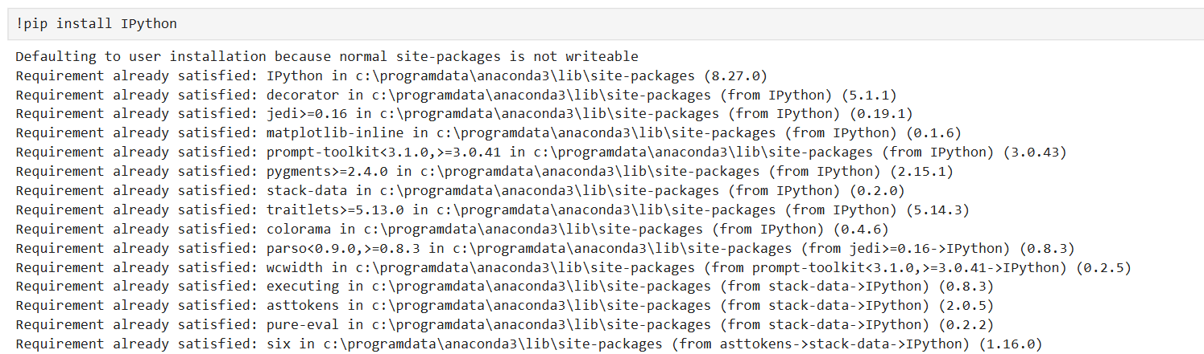

**Step3 -** Reading the csv data into a dataframe.

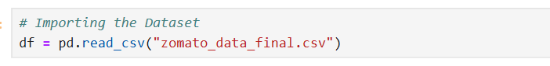

**Step 3 -** Import required library - **folium and IPython**

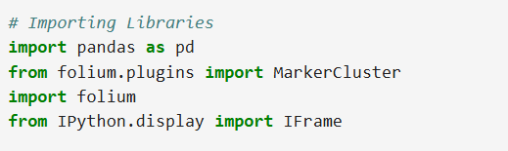

**Step 4 -** Cuisine-Specific Map – Italian Restaurants

**1.Objective**

The main aim is to visualize restaurant locations on a map to understand their density in a city.

### **2.Filter the Data**

Select only those restaurants from the dataset that offer **Italian cuisine**.

### **3. Create the Map**

Initialize a map centered on the city (e.g., Bangalore) to plot Italian restaurants.

### **4.Add Restaurant Markers**

### Loop through the filtered data and place a **purple marker** for each Italian restaurant using its latitude and longitude.

### **5.Show Restaurant Details**

Each marker displays a popup with details like:

* City name
* Type of cuisine (Italian and possibly others)

### **6.Save the Map**

The map is saved as an HTML file so it can be opened and viewed in any browser.

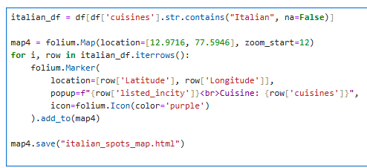

**Step 5-** Displaying the Map in a Notebook

### **1.Purpose**

To view the saved interactive restaurant density map directly within a Jupyter Notebook.

### **2.Use IFrame**

The IFrame function from IPython.display is used to embed the HTML file (restaurant_density.html) into the notebook.

### **3.Set Dimensions**

The width and height are specified to control how large the map appears in the output cell.

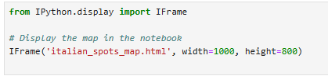

**Output**

